Lab 04 – OpenIOC

In this lab, you’ll take a look at some Indicators of Compromise with the OpenIOC Editor. You’ll also create one of your own.

- Install the Mandiant IOC Editor on a Windows machine
  - The installer is included on your flash drive
  - It is already installed on the Windows 10 VM in the IA Lab, if you choose to use that
- Open Mandiant IOCe
  - The tool will ask you to open a folder of IOCs. Open the openioc_examples folder
- Using the provided example IOCs, become familiar with the syntax.
  - Remember: all sides of a boolean AND expression must be true for the statement to evaluate to true.
  - Remember: one or more sides of a boolean OR expression must be true for the statement to evaluate to true.
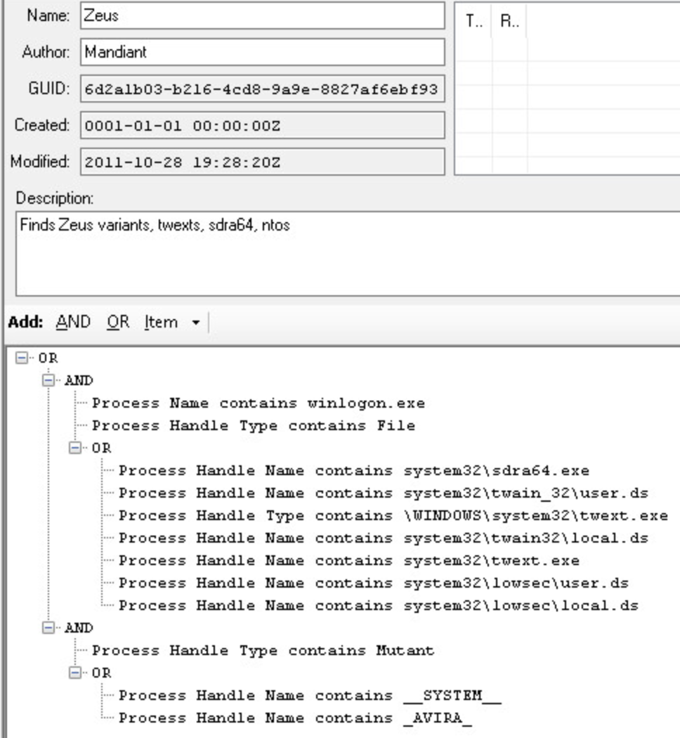
  - Note the metadata at the top, and the rule itself at the bottom
- Create your own IOC based on the following intelligence
  - File -> New -> Indicator

Name: SneakyKey
Category: Backdoor
Family: SNEAKY

Description: This SneakeyKey backdoor creates an open port on the affected system on port 1234, and allows attackers backdoor access into the system
MD5: 3517fb6a19bdf4c45032cac6b232ea58
Filename: sk.exe -or- sneak.exe -or- k.exe
File size: 5399
Directory: \Temp -or- \Temp\key
Strings:
Sneaky
Bakup
P1234

When you are finished, your IOC should look like this:
