Lab 10 – Kansa

- Log in to the Windows 10 VM using the password Password1!
- Right click on PowerShell in the bottom task bar, and click Run As Administrator
- Run the following commands
  - Set-ExecutionPolicy Unrestricted -Force
  - cd C:\Users\DSU\Desktop\Kansa-master\
  - ls -r *.ps1 | Unblock-File
- Before we run Kansa, generate a file with a list of hosts to run Kansa against
  - Open notepad and create a new document with two computer names on two lines. Save the document as hosts.txt in the Kansa-master directory.
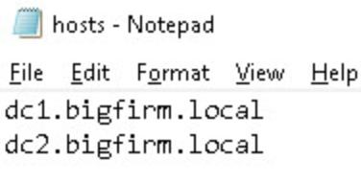
- Run Kansa against the two servers
  - .\kansa.ps1 -TargetList .\hosts.txt -Credential BIGFIRM\Administrator
    - Provide the password in the popup box Password1!
- Take a look at the data you just collected
  - In the Kansa-master directory, you should see an Output_ directory. Open that directory up and explore the contents.

