Lab 11 – Lateral Movement

Overview
Your job for this lab will be to exploit 2 separate targets and move laterally through those to the final target. This lab will be completed in the IA lab. Document your process and the methods that you use that you use to pivot through the various hosts. Use screenshots to show your pivoting setup.
You should use a different technique for moving laterally through the Windows host and Linux host. You can use the same final exploit shown in the video.

Network Diagram
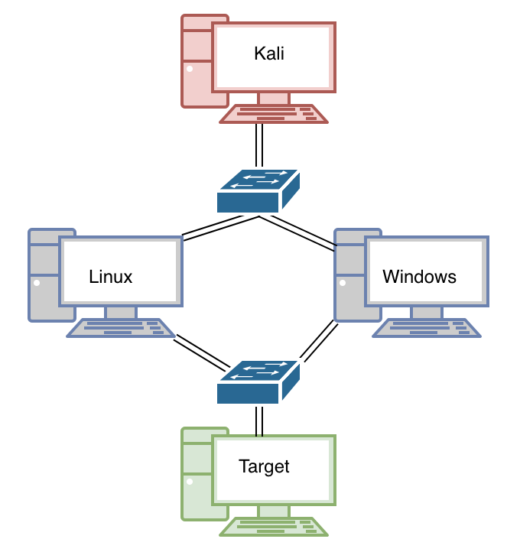

Notes
The final targets credentials are DSU:Password1! And if you are having trouble exploiting it check out the eternal blue psexec modules in Metasploit.

