Lab 3: using The SCADABR HMI
Estimated Time: 3 hours
Purpose: The purpose of this Lab exercise is to develop an.
Objective: Use Wireshark to observe Modbus traffic. Use Radzio to inject Modbus traffic to attack a PLC.
Lab Setup and Requirements: The student will need to have installed the OpenPLC runtime for Windows, the OpenPLC editor, and an Arduino Uno plus bread board. The student will install Wireshark and Radzio.

Download and setup
Step 1: Download and install Wireshark.
- Wireshark is a tool that allows observation of network traffic.
- Wireshark is available at https://www.wireshark.org/download.html
Step 2: Download and install Radzio.
- Radzio is a debug tool for Modbus. It can be used to poll and modify data at Modbus addresses. Rad
- Radzio is a easy tool to create injection attacks.
- Radzio can be downloaded here: http://en.radzio.dxp.pl/modbus-master-simulator/
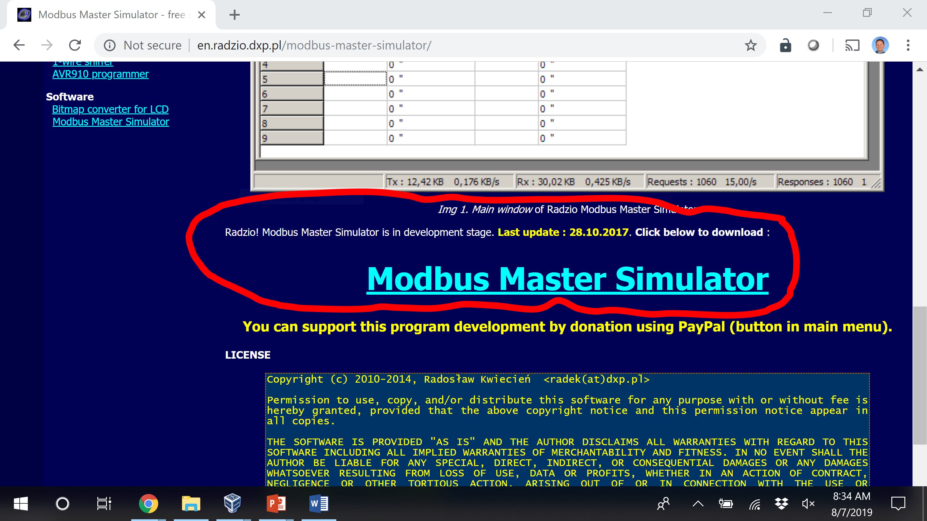
Step 3: Launch the SCADA system created for Lab 3.
- Start the runtime, the HMI, and have the system operational.

Using Wireshark with MODBus
Step 4: Wireshark
- First open Wireshark. When you open wireshark the tool presents a set of interfaces available for capture.
- Select the VirtualBox Host-Only Adapter. This is the network used to communicate between the Windows PLC and the SCADABr HMI.
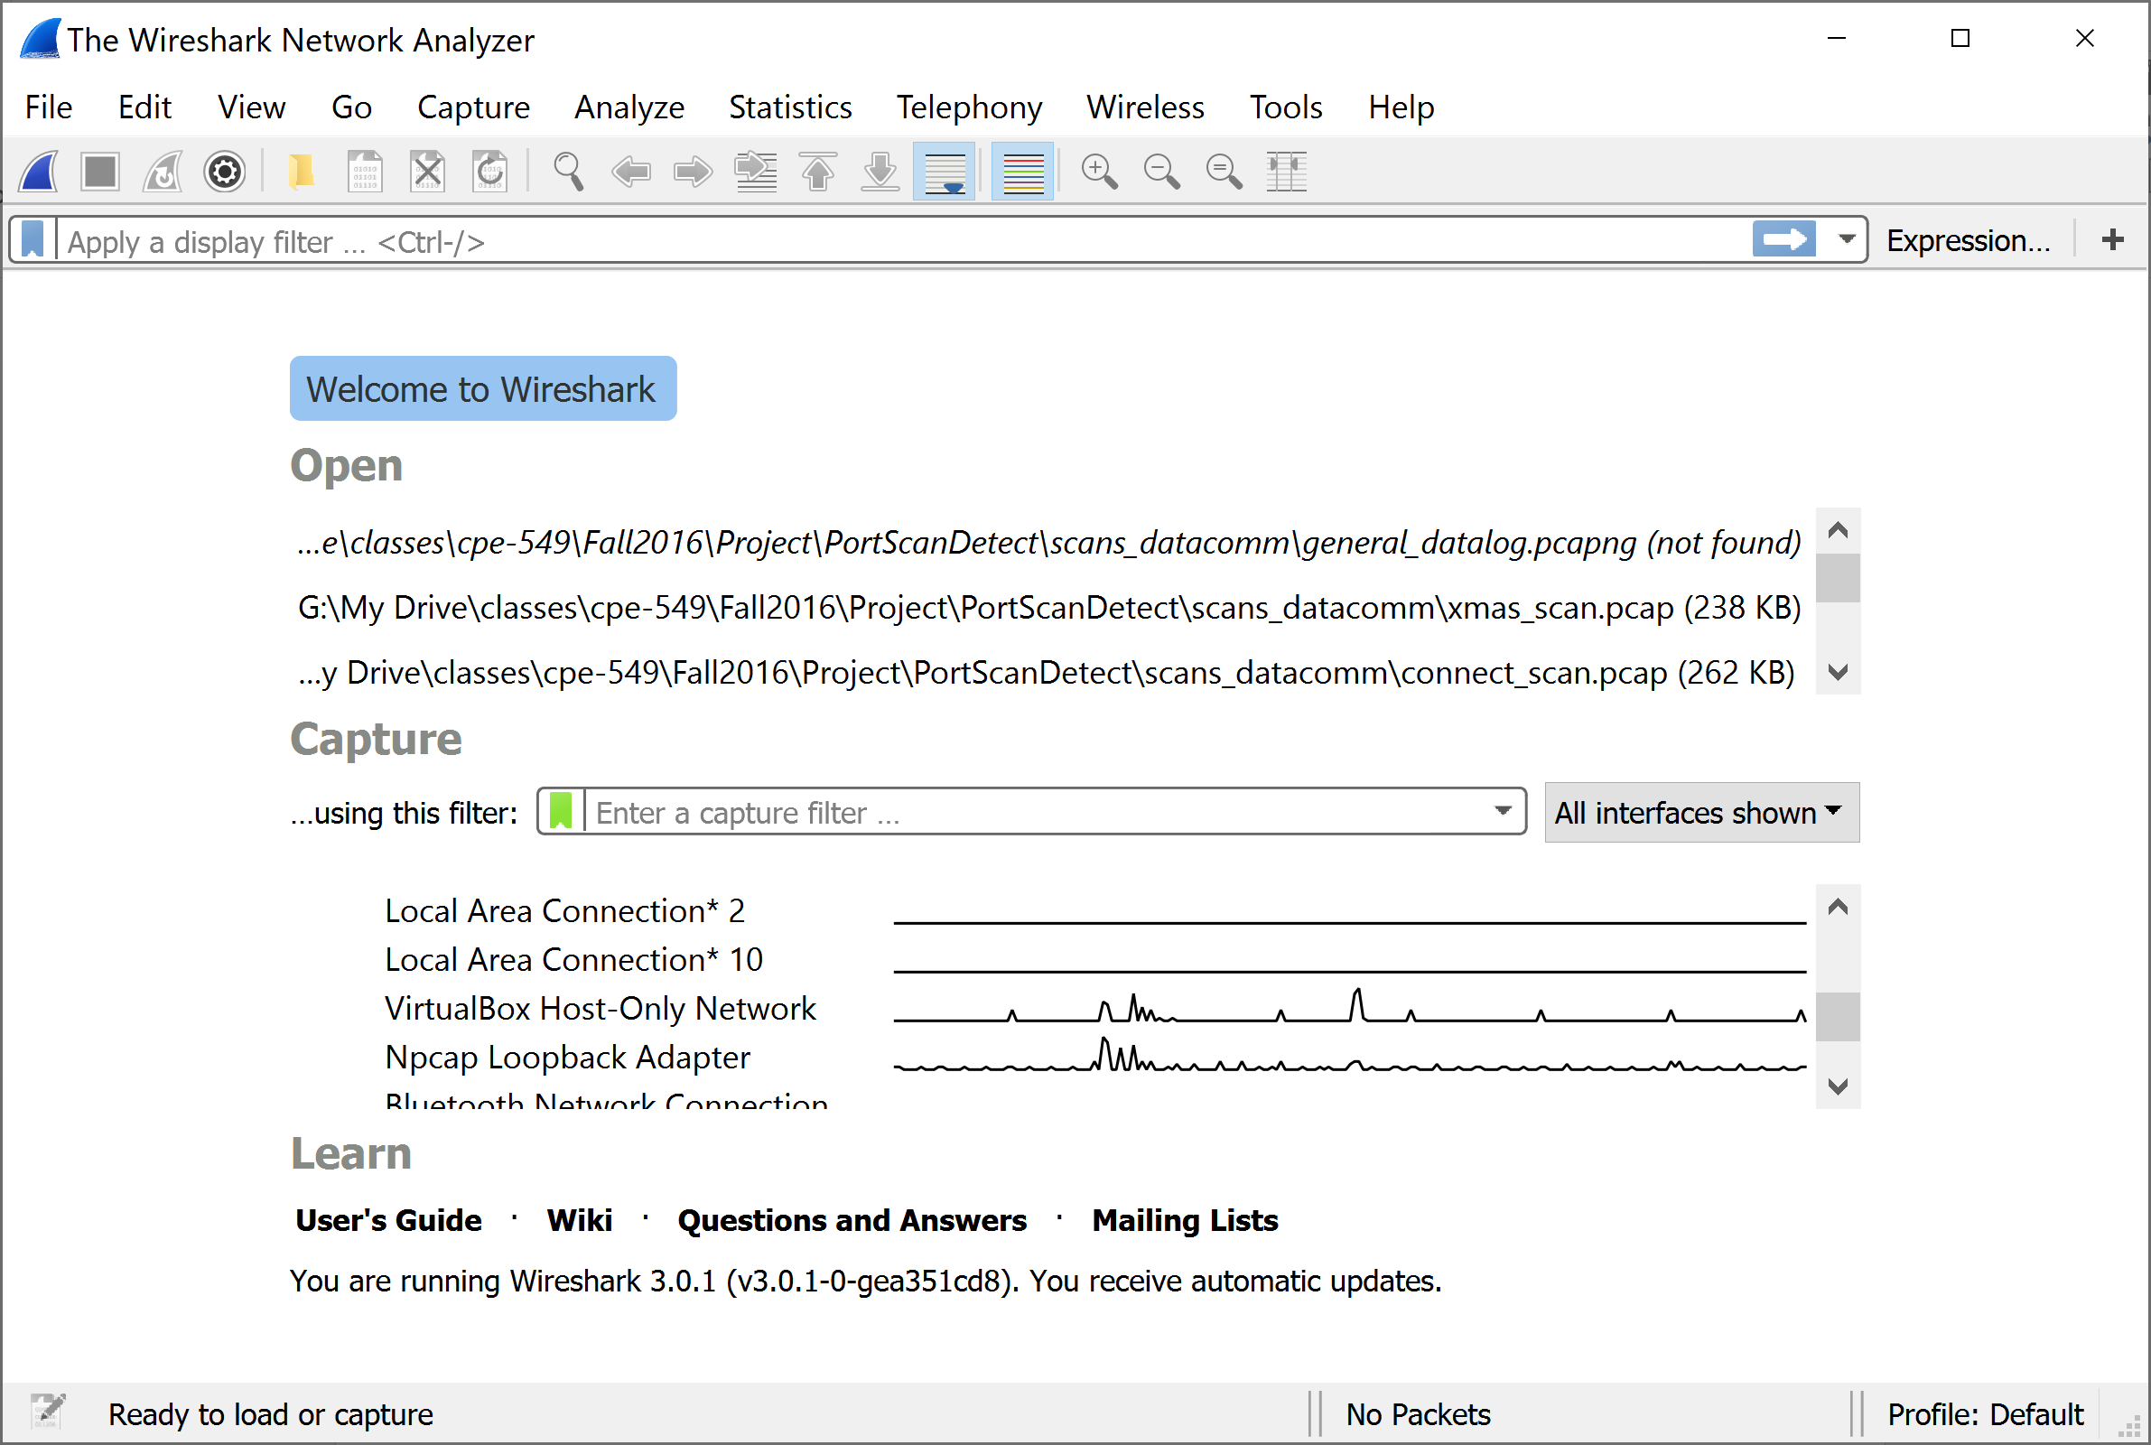
- When Wireshark begins capturing packets you will see them streaming by. Whireshark will continue to capture packets until stopped. Use the stop button to stop the capture.
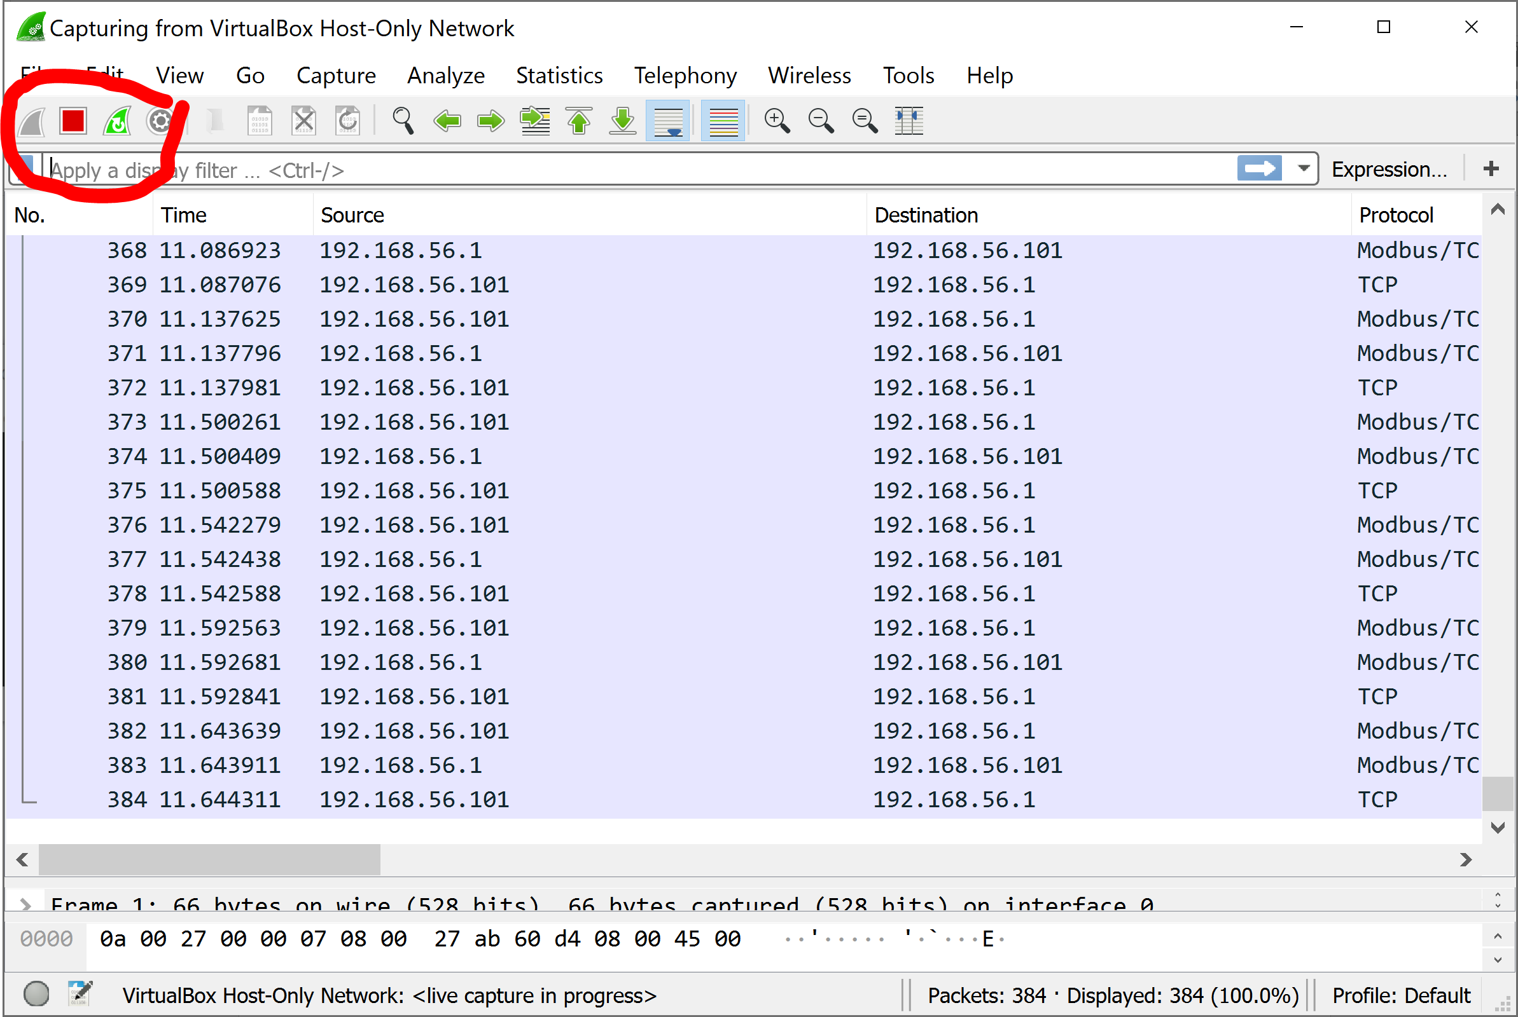
- Double click on a Modbus packet to investigate its contents.
  - Double click on another packet.
  - Find a server and a client packet. Modbus servers use port 502. Modbus client TCP ports are ephemeral.
  - What is the server IP address? __________________________
  - What is the client IP address? ___________________________
- Choose a Modbus client to server packet. This is a Modbus request. What is this packet doing?
  - What is the Modbus function code?
  - Use the Modbus Application specification to look up the function code?
http://www.modbus.org/docs/Modbus_Application_Protocol_V1_1b3.pdf
  - Is this packet a read request?
    - What is the Modbus address being read?
    - How many registers are being read?
    - Does this Modbus query match a data source in your Lab 03 HMI?
    - Which one?
    - Note: Wireshark calls the Modbus address a reference number.
- Choose a Modbus server to client packet. This is a Modbus response. What is this packet doing?
  - What is the Modbus function code?
  - Use the Modbus Application specification to look up the function code? http://www.modbus.org/docs/Modbus_Application_Protocol_V1_1b3.pdf
  - What request does this packet respond to?
  - Is this packet a read response?
    - How many bytes were returned?
    - What Modbus address was returned?
    - What data was returned?
We can use Wireshark filters examine all of the Mobdus packets at once.
- First, the simplest filter is the name of a protocol. Type “modbus” in the wireshark filter field. This limits the display to only Modbus packets.
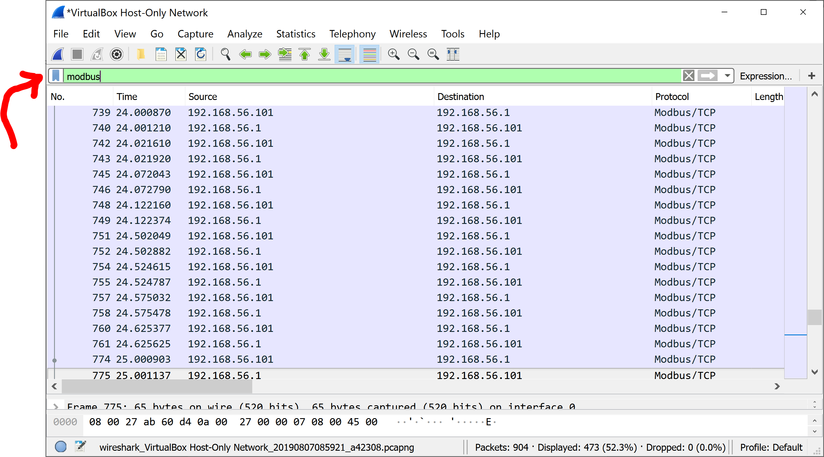
- When applying a filter, the number of packets displayed is shown at the bottom of the window. This is the number of packets which match your filter condition.
  - How many Modbus packets are in your Wireshark capture?
- Filters can be more powerful. Filters can match specific fields in a packet. For example, a filter may match a specific IP address, a specific TCP port, a specific Modbus function code, etc.
- Filters can be combined with combinatorial logic (and, or, etc) to be very specific.
- Write a filter to show only Modbus request packets.
  - This filter can search for all Modbus packets that have the source IP address. Alternatively, the filter can search for all Modbus packets with TCP destination packet 502. Try both.
  - Which of the above is more informative for the investigator? Why?
Answer: Filtering on the known Modbus address may not show packets from a network client you didn’t know about. Filtering for all packets with port 502 as the destination will show the know IP address and any that are not. If you really suspected a rogue client, a filter could look for port 502 as the destination when the source IP address is NOT the known good address.
- Write a filter to show all Modbus packets that are “Write Single Register” requests. Use the expression builder. Note: clear the expression field before starting a new expression.
  - You can look up the function code value for “Write Single Register” here: http://www.modbus.org/docs/Modbus_Application_Protocol_V1_1b3.pdf
  - The expression builder is available via a button on the right side of the expression field.
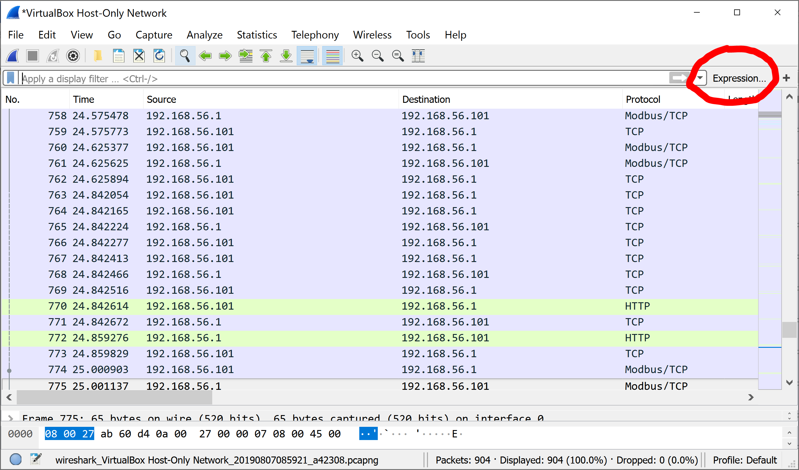
- In the expression builder, search for Modbus. Click on the “>” symbol to show available Modbus expressions.
- Scroll down to function code expression. Either type in the function code you are interested in or use a predefined value.
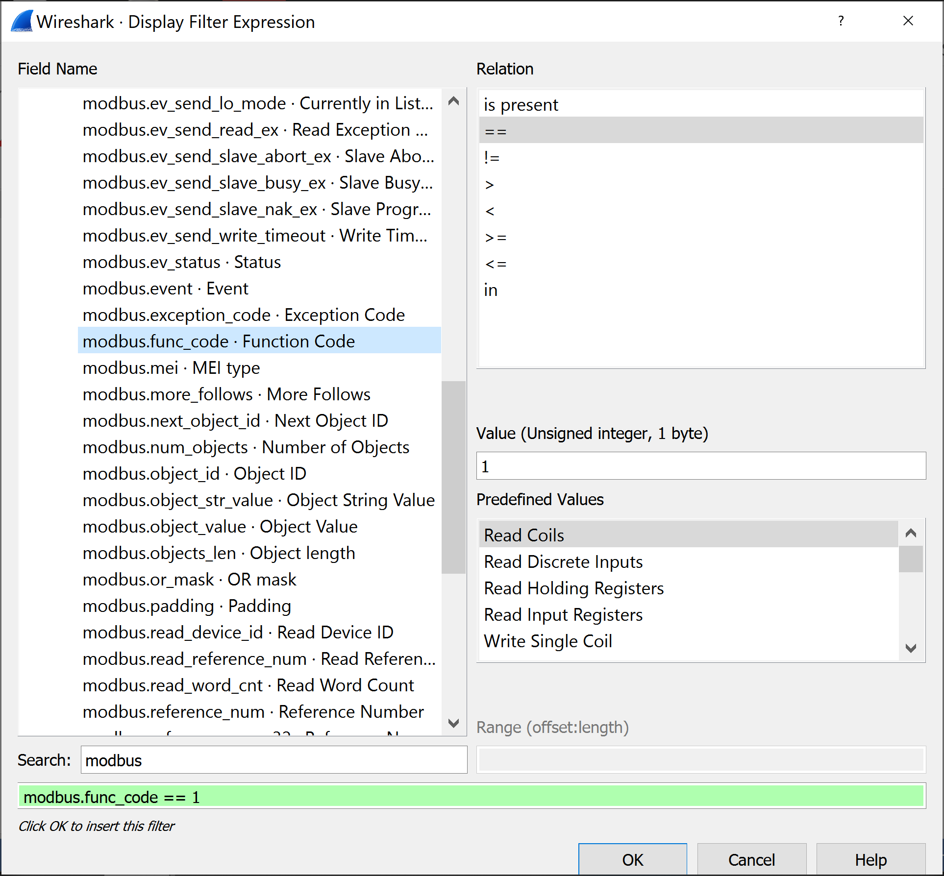

Using Radzio
Step 1: Start Radzio.
- Open the folder where you extracted the Radzio zip file. Launch the rmms.exe file.
Step 2: Open a connection.
- In the Radzio tool choose Connection->Settings.
- Change the protocol to Modbus TCP
- Change the Modbus TCP IP Address to match the IP address of your PLC. This is the same IP address you configured the HMI to use.
  - When using Virtual Box Host Only Adapter for networking the PLC IP address is the IP address of the host. This defaults to 192.168.56.1. It can be looked up or changed using the instructions here: https://www.thomas-krenn.com/en/wiki/Network_Configuration_in_VirtualBox#Host-only_Networking
- Note: You can find this IP address with NMAP. Look for IP addresses advertising a service on port 502.
- After configuring your connection, connect to the PLC server. Use Connection -> Connect. The bottom of the screen will now show connection details.
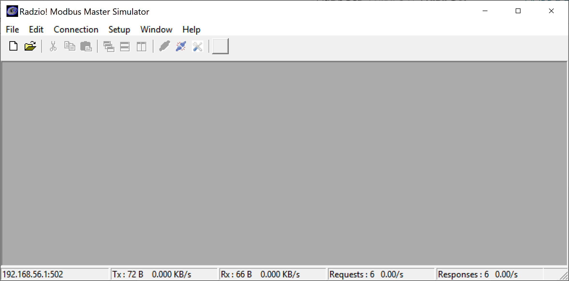
- Click the small white button on the top left to begin view Modbus data.
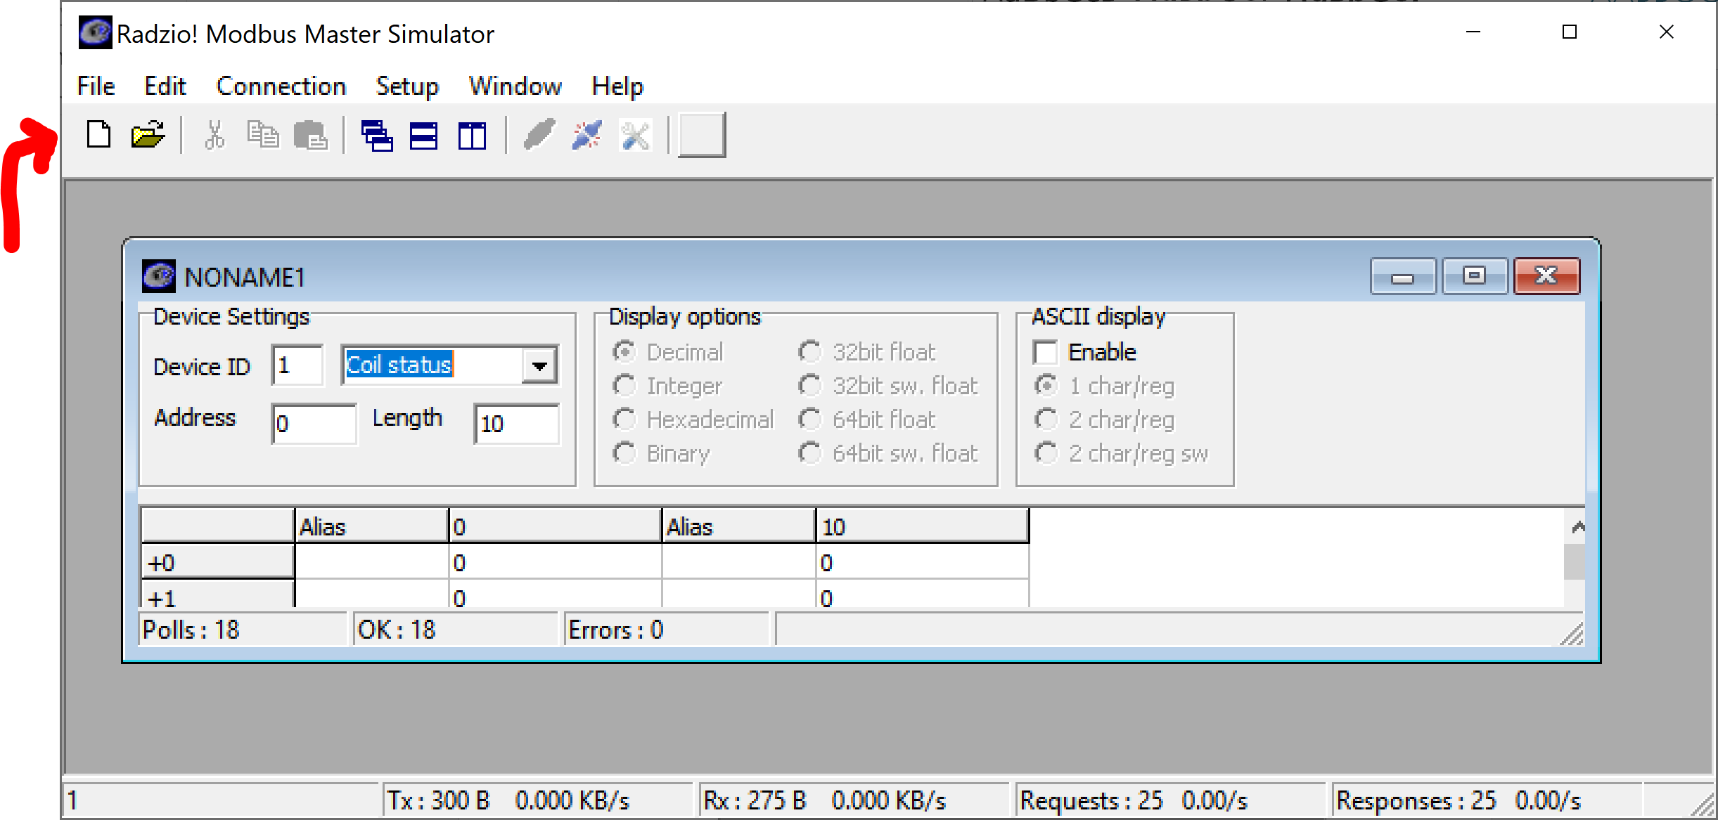
- Use the “Coil Status” drop down to change the data type. Available types are Coil Status, Input Status, Input Register, and Holding Register. Each of these has a different address range. To view data at a specific address and off a specific type, first set the type and then change the address. The length field tells Radzio how many data blocks (coils or registers) to fetch.
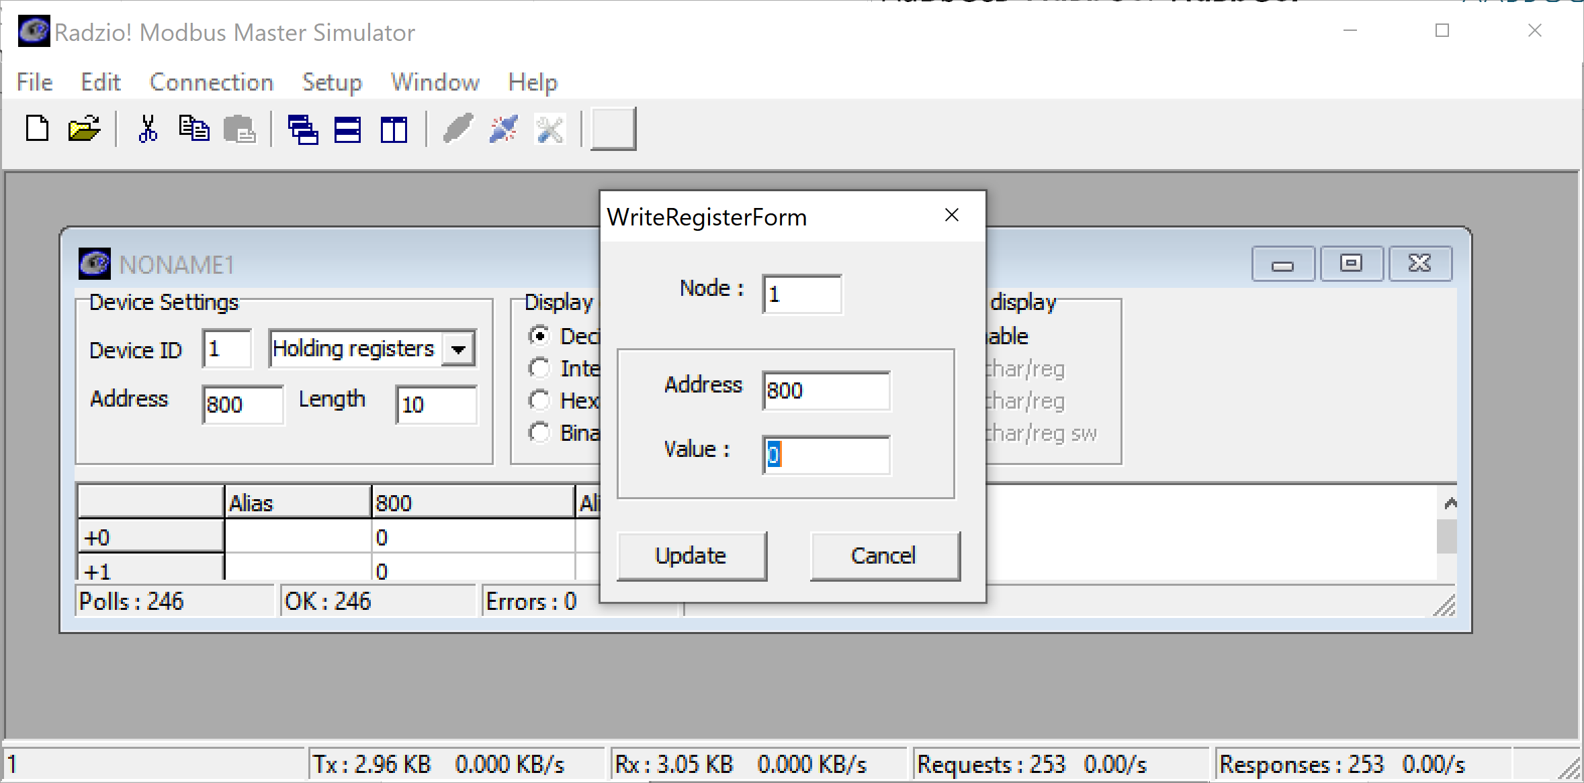
- Double click on a data field to modify that address’s contents. This will cause Radzio to write to that address. If that address is implemented by a PLC program it will change.
- Use Radzio to display your number1 and number2 registers from Lab 03.
- Overwrite the contents of number1 and number2 and observe the response in the HMI.
- Overwrite the contents of number1 and number2 in the HMI and observe the response in Radzio.
- Radzio is essentially a light weight HMI. It is a connection testing tool for engineers. It can also be used to reconnoiter PLC’s to observe what addresses are used and to overwrite data at specific addresses (a simple network injection attack).

