Security Design Principles

**Permission policies**

# Safe-Failure

Write a program that only allows access to users with the correct username and password. If either the username or password do not match, deny access. The only username and password that should allow access is:

USERNAME: johnd0e25

PASSWORD: password1!

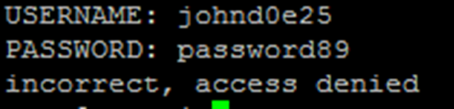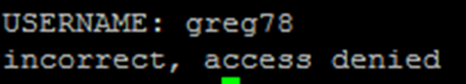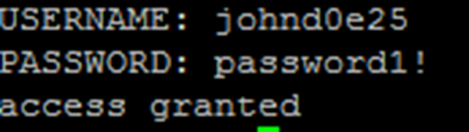

## What to submit

Send in a text file with your complete code written for this problem. Also include screenshots of your program when ran with both the incorrect and correct username and password.