Vulnerabilites

**password weakness**

# password hashing

In this lab, you will see how the “guess and check” method works using the leaked lists that are found online and some simple python code. You will run simple md5 hashes through a program that will check to see if the hash matches any of the passwords in a specified list of passwords. Check the last page of the document to see how the code works.

### **password hashing/step 1**

Open Kali VM and copy the code provided into a python program titled “hash.py”. Go to wiki link (<https://wiki.skullsecurity.org/Passwords>) and pull down “Hotmail.txt” and save it to your Desktop.

**PASSWORD HASHING/STEP 2**

Copy txt file from Desktop to root by typing in command “cp /root/Desktop/Hotmail.txt . “. Check that it copied correctly using command “ls”. Change the file that the code is running with to “Hotmail.txt” instead of “rockyou.txt”. Run these hashes through.

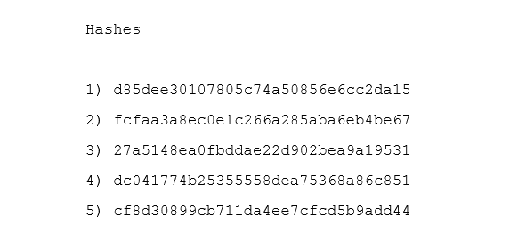

### **Puzzler**

Try to modify the code to make this program run faster/easier.

## What to submit

Submit screenshots of all 5 passwords after they were decoded using the hash-program. If you modified the code, submit that as well. Will not accept the passwords just typed in plain text. MUST be screenshots from terminal.

# Code

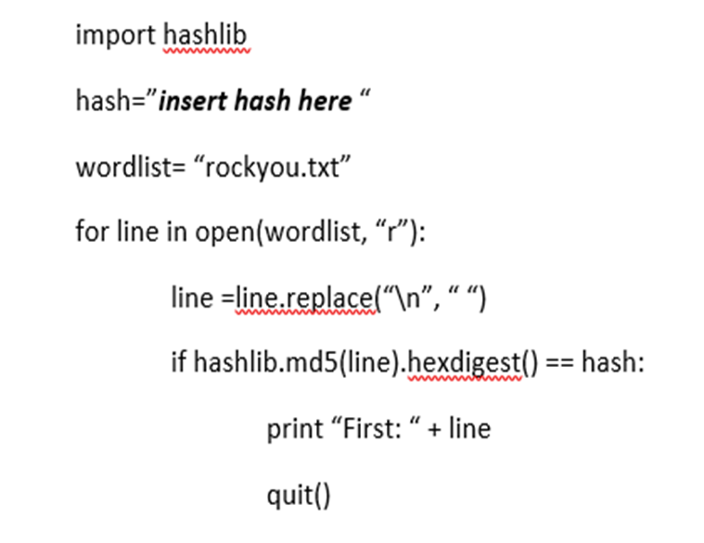

# How the code works

