Wireless Spectrum Regulation

**Lesson 1 – Wireless Spectrum Regulation**

# Lesson 1 lab Solutions

### **Antenna Structure Registration**

1. Visit the FCC’s website and review the Antenna Structure Registration process. What is the process?

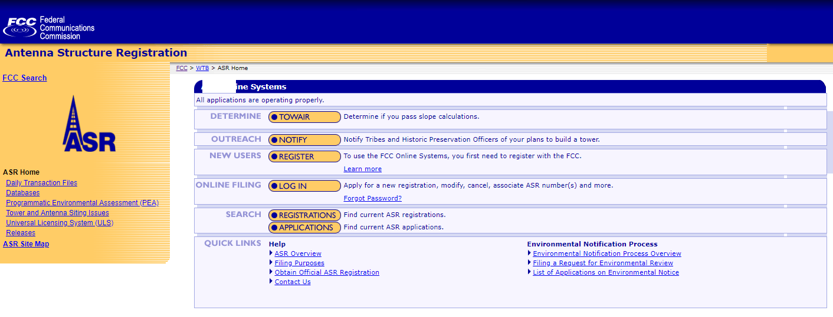

To register an Antenna, you must first create an account with the FCC. Then fill out an application on the FCC’s website and wait for approval.

1. Find some of the Antenna’s registered near you. What are they and what information can you find about them?

Clicking on Registrations



Brings you to their registration search page

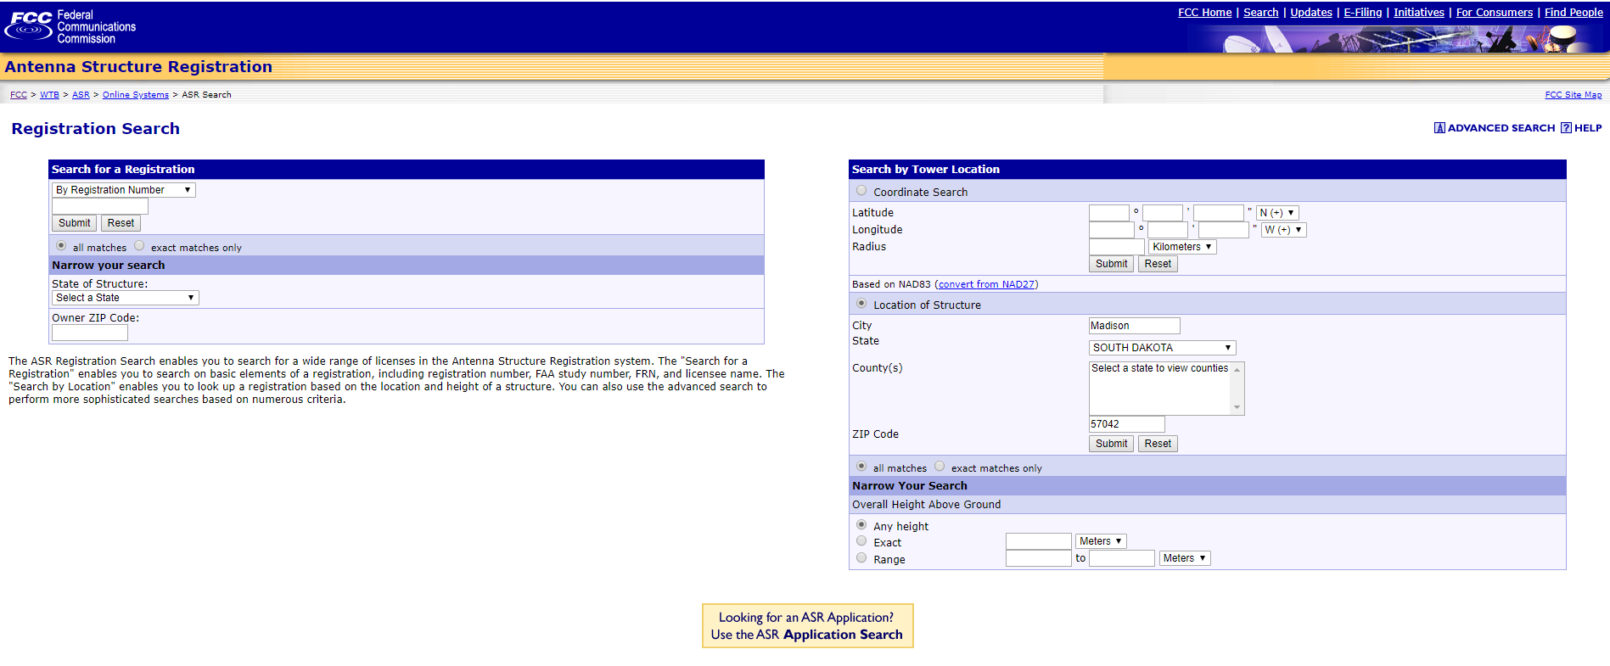

Where you can use the search by Tower Location

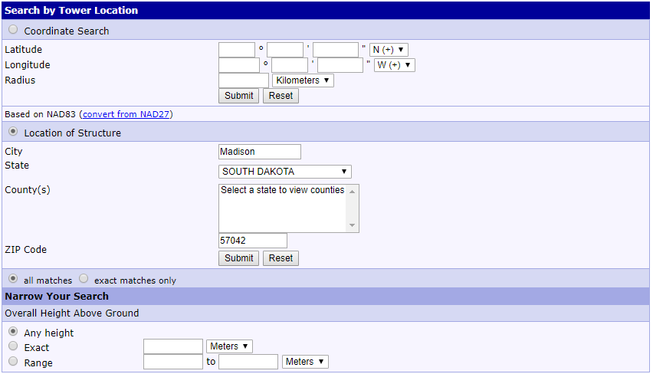

And obtain results such as these.

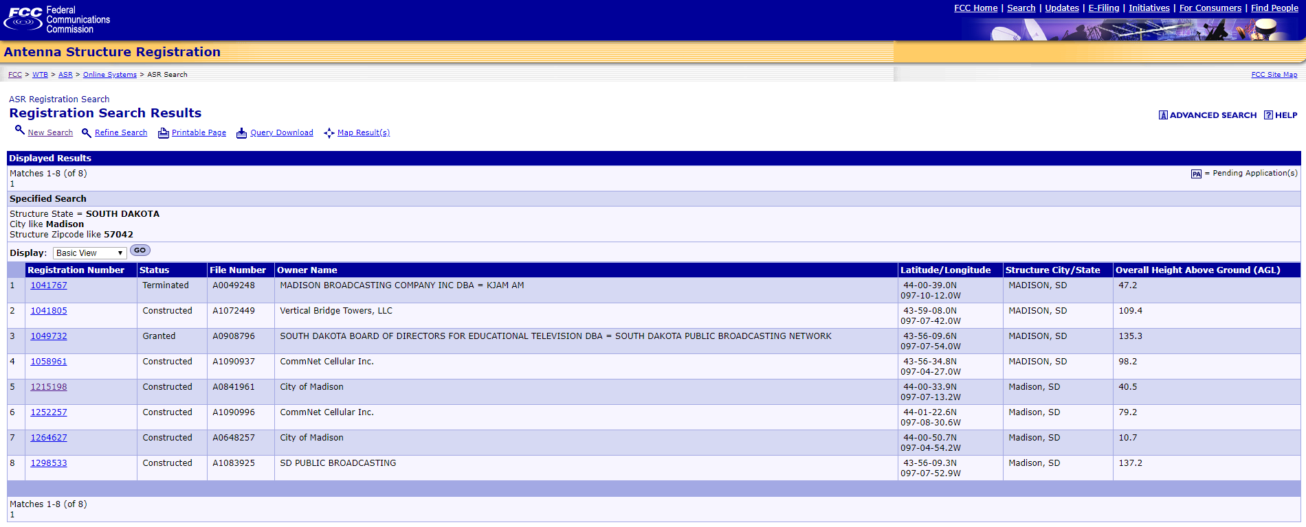

Furthermore, clicking on one of the registration numbers yields information about that particular Antenna structure.

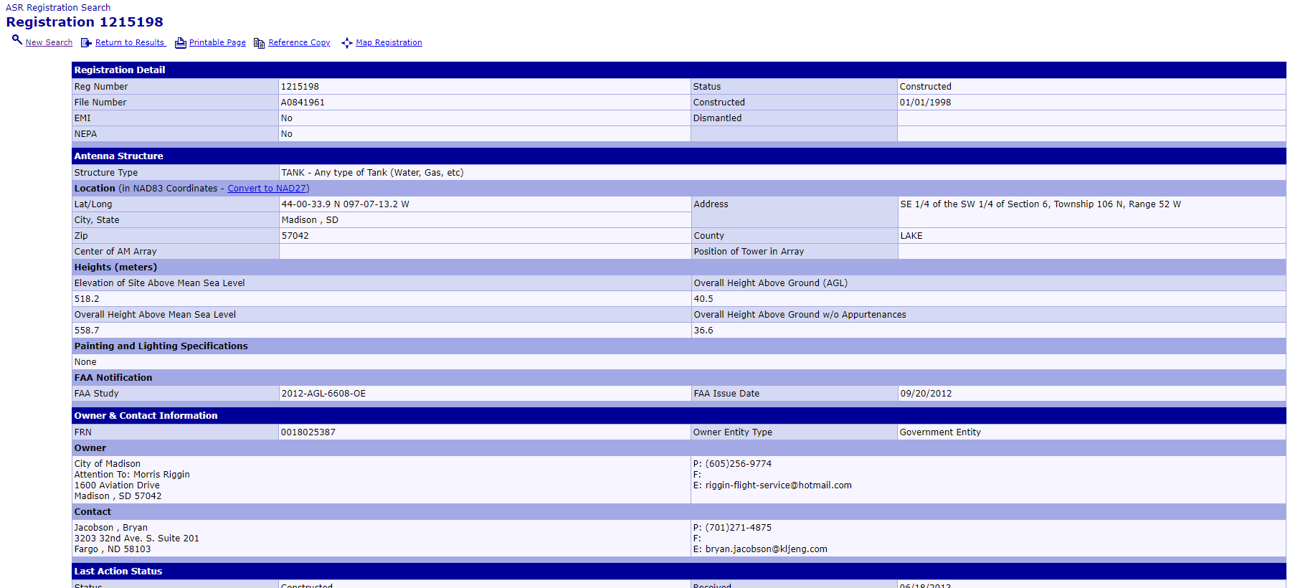

1. What do you think the purpose of having a registration system is?

The purpose of having a registration system is to keep air travel safe, as well as provide the FCC with the purpose of the tower and check to make sure that the tower is following all of the FCC’s regulations regarding wireless transmissions for the area.

### **Ham Radios**

1. How can you get certified to use a HAM Radio? What is the process?

In order to become certified for HAM radio, you must obtain a ham license by completing several exams depending on what level of license you would like to obtain.

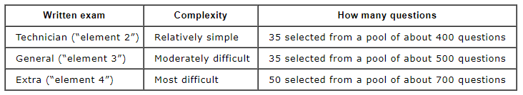

After completing the technician exam, you can begin using the radio but not access the entire spectrum. To access more of the spectrum the General and Extra exams can be taken.

1. What is the Spectrum Range that HAM Radios use?

The spectrum range used by HAM radios varies greatly, from low frequency at around 135.7 to 137.8 kHz to medium frequencies from around 3.5 to 29.7 MHz and finally high frequencies from 50 to 2310 MHz.

1. What are some of the protocols a HAM Radio user must follow when communicating using a radio?

One example of a protocol that must be used is always identifying yourself every ten minutes and at the end of a communication using your call sign. Even if just testing, a call sign must be used. Another example is saying “CQ” three times when calling.

1. Can you use a HAM Radio without a license?

You do not need a license to listen to a HAM radio but in order to transmit a FCC license must be obtained.