Cellular and mobile communications

**waves**

# Wave modulation

Draw the modulated wave from the given signal wave with amplitude modulation and frequency modulation then answer two short questions.

### **Wave 1**

AM

FM

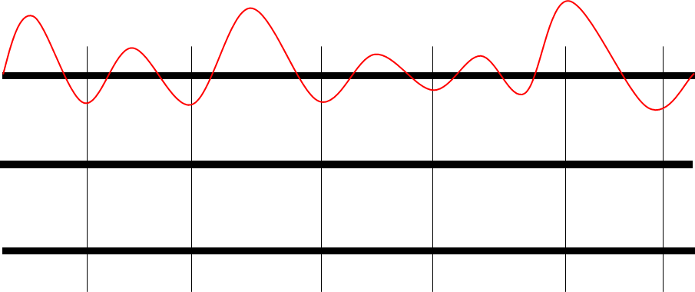**WAVE 2**

AM

FM

## Questions

1. Why is AM able to reflect off of the Ionosphere easily while FM is not?
2. Which form of modulation requires less power on average?