Wireless Spectrum Regulation

**Lesson 1 – Wireless Spectrum Regulation**

# Lesson 1 lab Solutions

### **ANALYzing ThE ZIGBEE PCAP**

1. In several of the packets sent there is a source of 0x0000, what is the significance of this?

This is the network ID of the ZigBee network or PAN ID (Personal Area Network)

1. What are the four major categories of the MAC frames ZigBee devices use?

Beacon, Data, Acknowledgement, and MAC command

1. What version of the protocol ZigBee is being used?

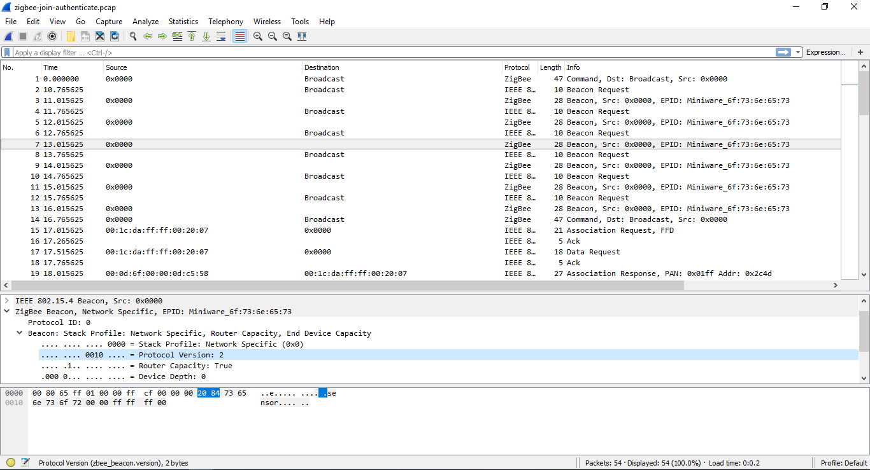

Version 2 – this can be found under ZigBee Beacon – Beacon.

1. What are the protocol(s) in the ZigBee packet capture? Research some into it(them) and see what you can find.

IEEE 802.15.4 – this covers the physical and MAC layer for the ZigBee protocol.

ZigBee – this is what “creates” the actual network construction, and allows applications/devices to communicate

1. What do you think are some reasons why ZigBee is being used?

ZigBee is used for applications that don’t need a high data rate. Such as Home Automation like thermostats or some smart devices. It is also used for communication with sensors in buildings and industrial plants. The use of ZigBee allows for low power consumption as some of these devices have very limited batteries.